Ryan Wandera
BSCCS/2024/34339
Mount Kenya University
Michael nNyoro
Ethical Hacking and Counter Measures

Table of Content

Task 1: Website vulnerability testing 3
Tool Specification 3
Screenshots 3
ZAP by Checkmarx Scanning Report 8
Taks 2 23
Organization Information 23
Task 3 27
Target System 27

Task 1: Website vulnerability testing

Tool Specification
Specification Details
Tool Name OWASP ZAP (Zed Attack Proxy)
Developer OWASP Foundation
License Open Source
Platform Windows, Linux, macOS
Language Java
Purpose Web Application Vulnerability Testing
Features Spidering, Passive Scanning, Active Scanning, Report Generation
GUI Support Yes

Screenshots
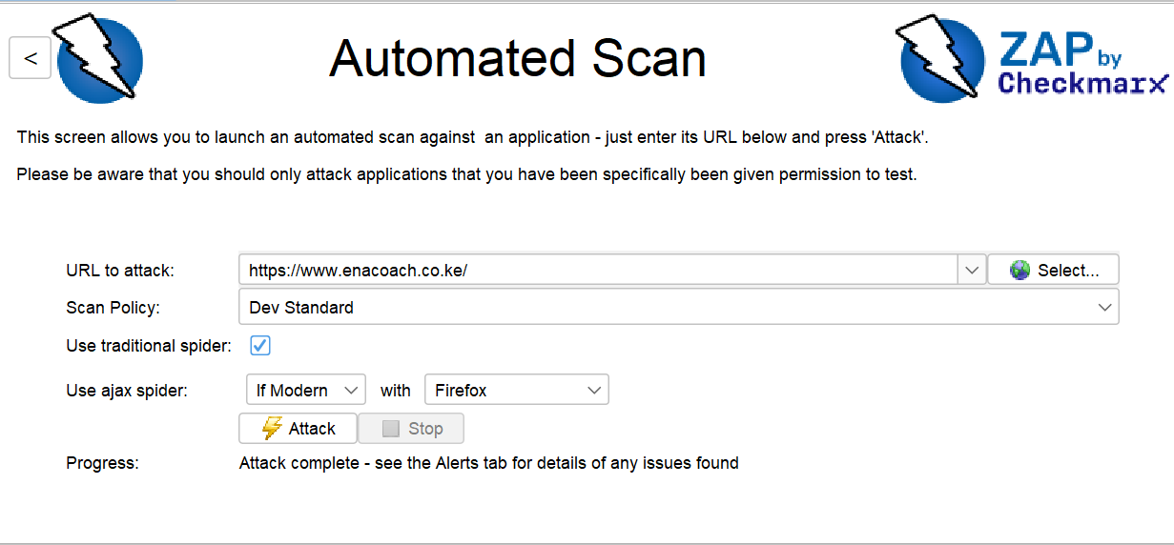

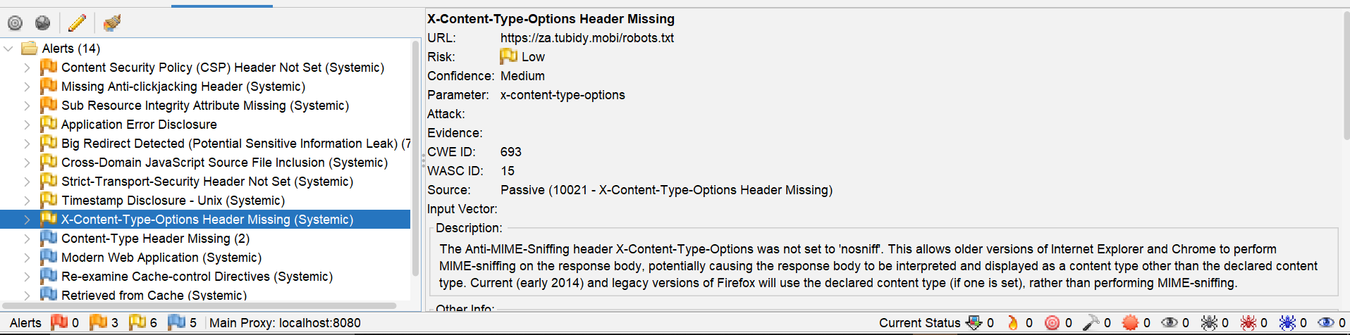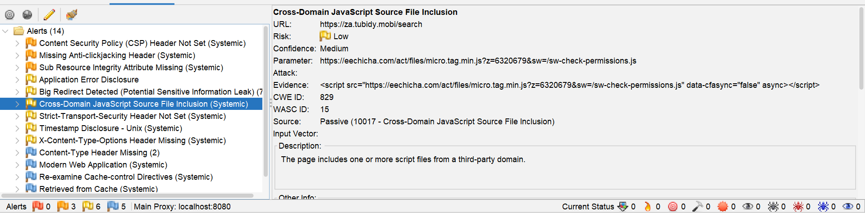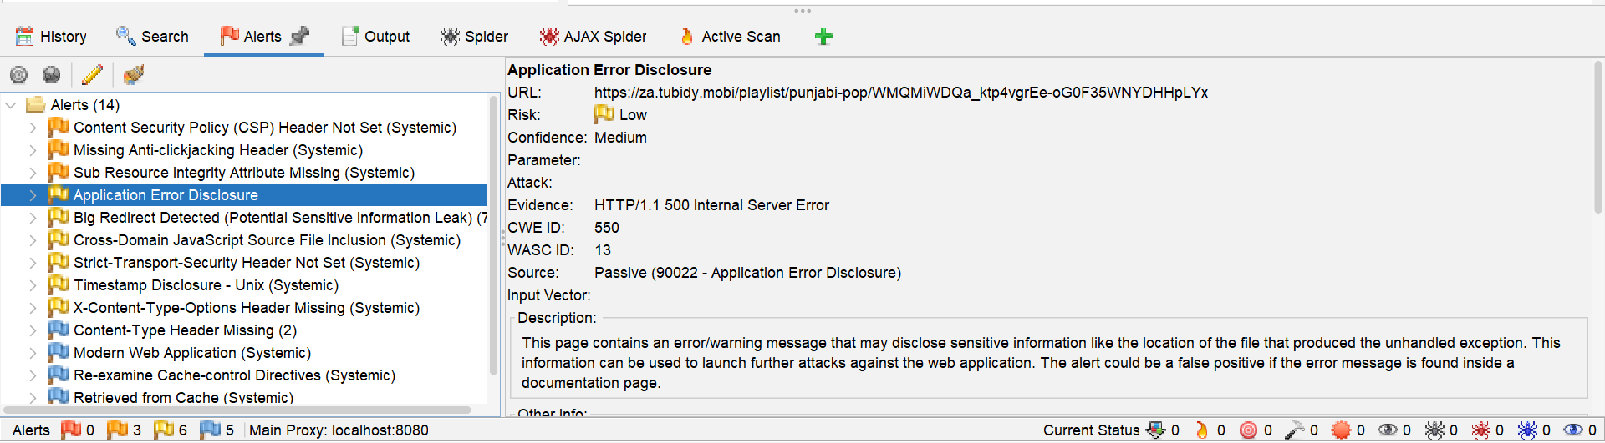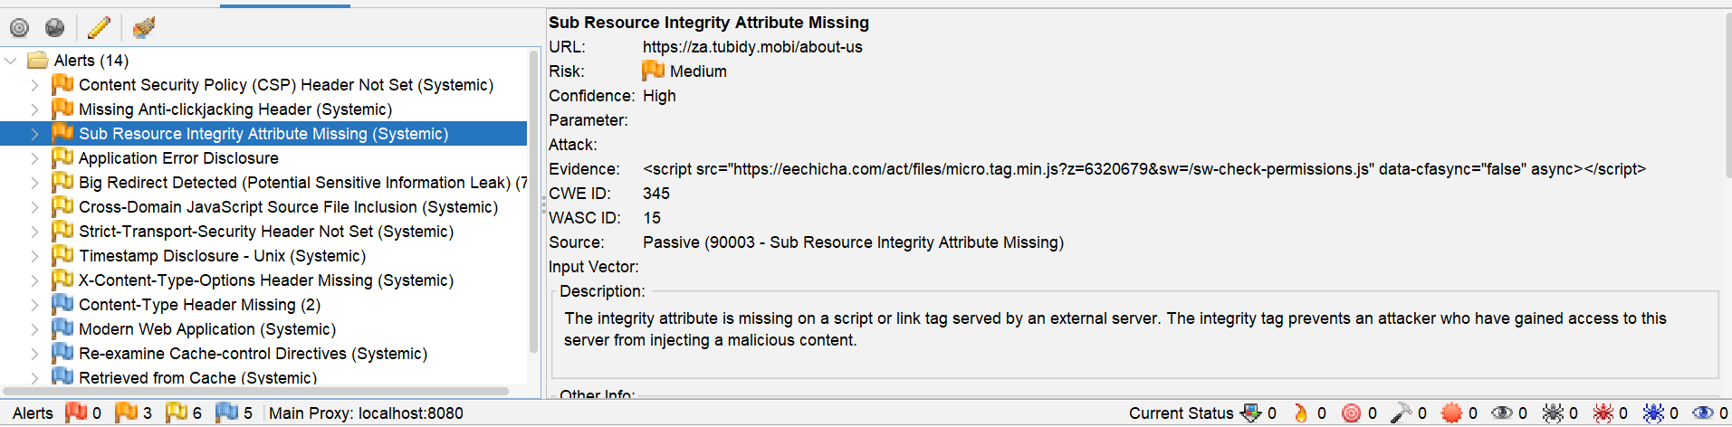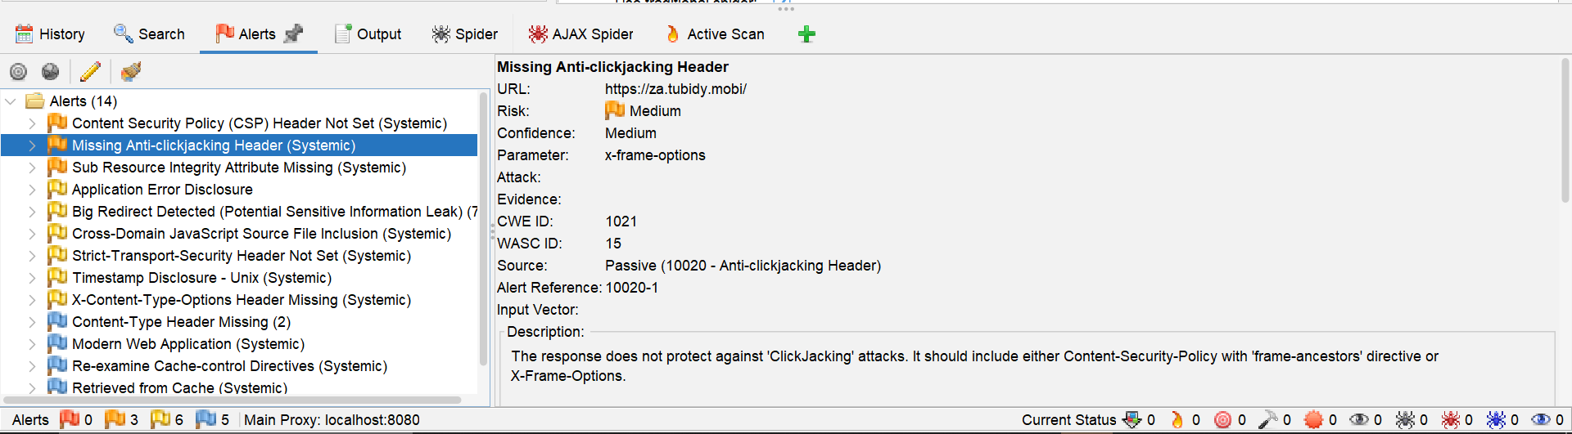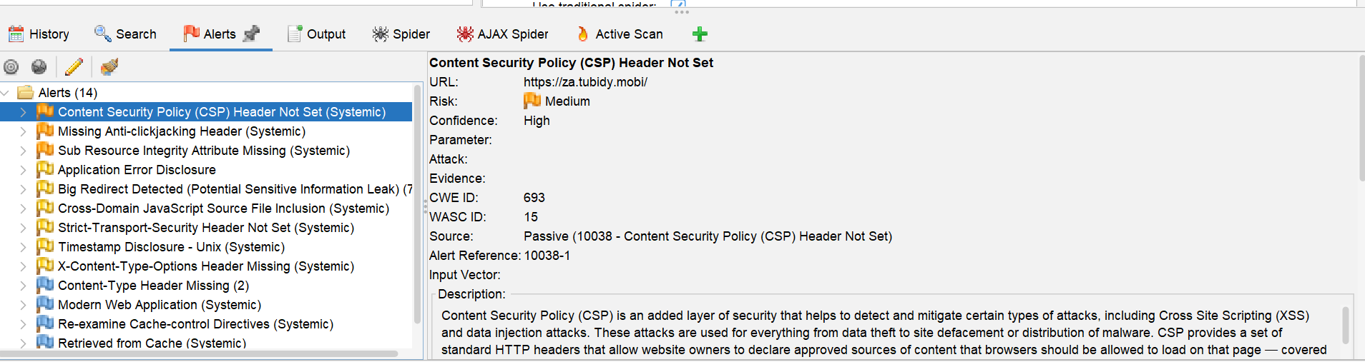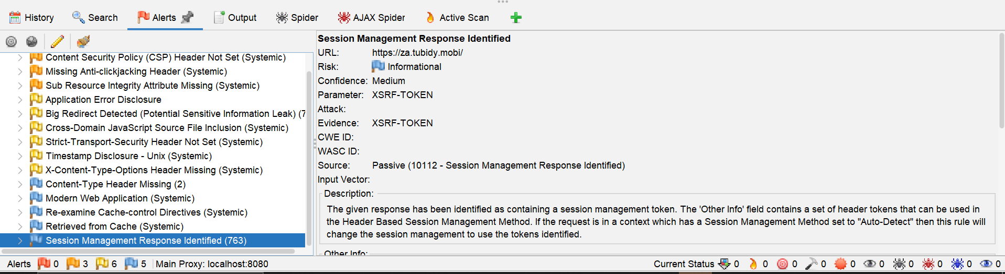

ZAP by Checkmarx Scanning Report
Generated with The ZAP logoZAP on Thu 11 Jun 2026, at 12:27:45

ZAP Version: 2.17.0

ZAP by Checkmarx

Contents
About This Report
Report Parameters
Summaries
Alert Counts by Risk and Confidence
Alert Counts by Site and Risk
Alert Counts by Alert Type
Insights
Alerts
Risk=Medium, Confidence=High (2)
Risk=Medium, Confidence=Medium (1)
Risk=Low, Confidence=High (1)
Risk=Low, Confidence=Medium (4)
Risk=Low, Confidence=Low (1)
Risk=Informational, Confidence=Medium (4)
Risk=Informational, Confidence=Low (1)
Appendix
Alert Types
About This Report
Report Parameters
Contexts
No contexts were selected, so all contexts were included by default.

Sites
The following sites were included:

https://www.enacoach.co.ke
https://za.tubidy.mobi
(If no sites were selected, all sites were included by default.)

An included site must also be within one of the included contexts for its data to be included in the report.

Risk levels
Included: High, Medium, Low, Informational

Excluded: None

Confidence levels
Included: User Confirmed, High, Medium, Low

Excluded: User Confirmed, High, Medium, Low, False Positive

Summaries
Alert Counts by Risk and Confidence
This table shows the number of alerts for each level of risk and confidence included in the report.

(The percentages in brackets represent the count as a percentage of the total number of alerts included in the report, rounded to one decimal place.)

Confidence
User Confirmed High Medium Low Total
Risk High 0
(0.0%) 0
(0.0%) 0
(0.0%) 0
(0.0%) 0
(0.0%)
Medium 0
(0.0%) 2
(14.3%) 1
(7.1%) 0
(0.0%) 3
(21.4%)
Low 0
(0.0%) 1
(7.1%) 4
(28.6%) 1
(7.1%) 6
(42.9%)
Informational 0
(0.0%) 0
(0.0%) 4
(28.6%) 1
(7.1%) 5
(35.7%)
Total 0
(0.0%) 3
(21.4%) 9
(64.3%) 2
(14.3%) 14
(100%)
Alert Counts by Site and Risk
This table shows, for each site for which one or more alerts were raised, the number of alerts raised at each risk level.

Alerts with a confidence level of "False Positive" have been excluded from these counts.

(The numbers in brackets are the number of alerts raised for the site at or above that risk level.)

Risk
High
(= High) Medium
(>= Medium) Low
(>= Low) Informational
(>= Informational)
Site https://www.enacoach.co.ke 0
(0) 0
(0) 0
(0) 1
(1)
https://za.tubidy.mobi 0
(0) 3
(3) 6
(9) 4
(13)
Alert Counts by Alert Type
This table shows the number of alerts of each alert type, together with the alert type's risk level.

(The percentages in brackets represent each count as a percentage, rounded to one decimal place, of the total number of alerts included in this report.)

Alert type Risk Count
Content Security Policy (CSP) Header Not Set Medium 8
(57.1%)
Missing Anti-clickjacking Header Medium 6
(42.9%)
Sub Resource Integrity Attribute Missing Medium 7
(50.0%)
Application Error Disclosure Low 1
(7.1%)
Big Redirect Detected (Potential Sensitive Information Leak) Low 7
(50.0%)
Cross-Domain JavaScript Source File Inclusion Low 5
(35.7%)
Strict-Transport-Security Header Not Set Low 10
(71.4%)
Timestamp Disclosure - Unix Low 5
(35.7%)
X-Content-Type-Options Header Missing Low 10
(71.4%)
Content-Type Header Missing Informational 2
(14.3%)
Modern Web Application Informational 6
(42.9%)
Re-examine Cache-control Directives Informational 6
(42.9%)
Retrieved from Cache Informational 5
(35.7%)
Session Management Response Identified Informational 763
(5,450.0%)
Total 14
Insights
This table shows information that is likely to be very relevant to you, but which is not related to vulnerabilities, or potentially even related to the application in question.

Level Reason Site Description Statistic
Low
Warning
ZAP errors logged - see the zap.log file for details
19
Low
Warning
ZAP warnings logged - see the zap.log file for details
36,639
Info
Informational
Percentage of network failures
6 %
Info
Informational
https://www.enacoach.co.ke
Percentage of responses with status code 2xx
89 %
Info
Informational
https://www.enacoach.co.ke
Percentage of responses with status code 4xx
10 %
Info
Informational
https://www.enacoach.co.ke
Percentage of endpoints with content type application/javascript
57 %
Info
Informational
https://www.enacoach.co.ke
Percentage of endpoints with content type image/png
14 %
Info
Informational
https://www.enacoach.co.ke
Percentage of endpoints with content type text/css
4 %
Info
Informational
https://www.enacoach.co.ke
Percentage of endpoints with content type text/html
14 %
Info
Informational
https://www.enacoach.co.ke
Percentage of endpoints with method GET
100 %
Info
Informational
https://www.enacoach.co.ke
Count of total endpoints
21
Info
Informational
https://www.enacoach.co.ke
Percentage of slow responses
100 %
Info
Informational
https://za.tubidy.mobi
Percentage of responses with status code 2xx
97 %
Info
Informational
https://za.tubidy.mobi
Percentage of responses with status code 3xx
1 %
Info
Informational
https://za.tubidy.mobi
Percentage of responses with status code 4xx
1 %
Info
Informational
https://za.tubidy.mobi
Percentage of endpoints with content type application/javascript
1 %
Info
Informational
https://za.tubidy.mobi
Percentage of endpoints with content type image/png
1 %
Info
Informational
https://za.tubidy.mobi
Percentage of endpoints with content type image/svg+xml
1 %
Info
Informational
https://za.tubidy.mobi
Percentage of endpoints with content type image/x-icon
1 %
Info
Informational
https://za.tubidy.mobi
Percentage of endpoints with content type text/css
1 %
Info
Informational
https://za.tubidy.mobi
Percentage of endpoints with content type text/html
98 %
Info
Informational
https://za.tubidy.mobi
Percentage of endpoints with content type text/plain
1 %
Info
Informational
https://za.tubidy.mobi
Percentage of endpoints with content type text/xml
1 %
Info
Informational
https://za.tubidy.mobi
Percentage of endpoints with method GET
100 %
Info
Informational
https://za.tubidy.mobi
Count of total endpoints
773
Info
Informational
https://za.tubidy.mobi
Percentage of slow responses
99 %
Alerts
Risk=Medium, Confidence=High (2)
https://za.tubidy.mobi (2)
Content Security Policy (CSP) Header Not Set (1)
GET https://za.tubidy.mobi/
Sub Resource Integrity Attribute Missing (1)
GET https://za.tubidy.mobi/about-us
Risk=Medium, Confidence=Medium (1)
https://za.tubidy.mobi (1)
Missing Anti-clickjacking Header (1)
GET https://za.tubidy.mobi/
Risk=Low, Confidence=High (1)
https://za.tubidy.mobi (1)
Strict-Transport-Security Header Not Set (1)
GET https://za.tubidy.mobi/robots.txt
Risk=Low, Confidence=Medium (4)
https://za.tubidy.mobi (4)
Application Error Disclosure (1)
GET https://za.tubidy.mobi/playlist/punjabi-pop/WMQMiWDQa_ktp4vgrEe-oG0F35WNYDHHpLYx
Big Redirect Detected (Potential Sensitive Information Leak) (1)
GET https://za.tubidy.mobi/download
Cross-Domain JavaScript Source File Inclusion (1)
GET https://za.tubidy.mobi/search
X-Content-Type-Options Header Missing (1)
GET https://za.tubidy.mobi/robots.txt
Risk=Low, Confidence=Low (1)
https://za.tubidy.mobi (1)
Timestamp Disclosure - Unix (1)
GET https://za.tubidy.mobi/about-us
Risk=Informational, Confidence=Medium (4)
https://www.enacoach.co.ke (1)
Content-Type Header Missing (1)
GET https://www.enacoach.co.ke/manifest.webmanifest
https://za.tubidy.mobi (3)
Modern Web Application (1)
GET https://za.tubidy.mobi/
Retrieved from Cache (1)
GET https://za.tubidy.mobi/theme3/assets/favicon-BCxRQ_sU.ico
Session Management Response Identified (1)
GET https://za.tubidy.mobi/
Risk=Informational, Confidence=Low (1)
https://za.tubidy.mobi (1)
Re-examine Cache-control Directives (1)
GET https://za.tubidy.mobi/robots.txt
Appendix
Alert Types
This section contains additional information on the types of alerts in the report.

Content Security Policy (CSP) Header Not Set
Source raised by a passive scanner (Content Security Policy (CSP) Header Not Set)
CWE ID 693
WASC ID 15
Reference
https://developer.mozilla.org/en-US/docs/Web/HTTP/Guides/CSP
https://cheatsheetseries.owasp.org/cheatsheets/Content_Security_Policy_Cheat_Sheet.html
https://www.w3.org/TR/CSP/
https://w3c.github.io/webappsec-csp/
https://web.dev/articles/csp
https://caniuse.com/#feat=contentsecuritypolicy
https://content-security-policy.com/
Missing Anti-clickjacking Header
Source raised by a passive scanner (Anti-clickjacking Header)
CWE ID 1021
WASC ID 15
Reference
https://developer.mozilla.org/en-US/docs/Web/HTTP/Reference/Headers/X-Frame-Options
Sub Resource Integrity Attribute Missing
Source raised by a passive scanner (Sub Resource Integrity Attribute Missing)
CWE ID 345
WASC ID 15
Reference
https://developer.mozilla.org/en-US/docs/Web/Security/Subresource_Integrity
Application Error Disclosure
Source raised by a passive scanner (Application Error Disclosure)
CWE ID 550
WASC ID 13
Big Redirect Detected (Potential Sensitive Information Leak)
Source raised by a passive scanner (Big Redirect Detected (Potential Sensitive Information Leak))
CWE ID 201
WASC ID 13
Cross-Domain JavaScript Source File Inclusion
Source raised by a passive scanner (Cross-Domain JavaScript Source File Inclusion)
CWE ID 829
WASC ID 15
Strict-Transport-Security Header Not Set
Source raised by a passive scanner (Strict-Transport-Security Header)
CWE ID 319
WASC ID 15
Reference
https://cheatsheetseries.owasp.org/cheatsheets/HTTP_Strict_Transport_Security_Cheat_Sheet.html
https://owasp.org/www-community/Security_Headers
https://en.wikipedia.org/wiki/HTTP_Strict_Transport_Security
https://caniuse.com/stricttransportsecurity
https://datatracker.ietf.org/doc/html/rfc6797
Timestamp Disclosure - Unix
Source raised by a passive scanner (Timestamp Disclosure)
CWE ID 497
WASC ID 13
Reference
https://cwe.mitre.org/data/definitions/200.html
X-Content-Type-Options Header Missing
Source raised by a passive scanner (X-Content-Type-Options Header Missing)
CWE ID 693
WASC ID 15
Reference
https://learn.microsoft.com/en-us/previous-versions/windows/internet-explorer/ie-developer/compatibility/gg622941(v=vs.85)
https://owasp.org/www-community/Security_Headers
Content-Type Header Missing
Source raised by a passive scanner (Content-Type Header Missing)
CWE ID 345
WASC ID 12
Reference
https://learn.microsoft.com/en-us/previous-versions/windows/internet-explorer/ie-developer/compatibility/gg622941(v=vs.85)
Modern Web Application
Source raised by a passive scanner (Modern Web Application)
Re-examine Cache-control Directives
Source raised by a passive scanner (Re-examine Cache-control Directives)
CWE ID 525
WASC ID 13
Reference
https://cheatsheetseries.owasp.org/cheatsheets/Session_Management_Cheat_Sheet.html#web-content-caching
https://developer.mozilla.org/en-US/docs/Web/HTTP/Reference/Headers/Cache-Control
https://grayduck.mn/2021/09/13/cache-control-recommendations/
Retrieved from Cache
Source raised by a passive scanner (Retrieved from Cache)
CWE ID 525
Reference
https://datatracker.ietf.org/doc/html/rfc7234
https://datatracker.ietf.org/doc/html/rfc7231
https://www.rfc-editor.org/rfc/rfc9110.html
Session Management Response Identified
Source raised by a passive scanner (Session Management Response Identified)
Reference
https://www.zaproxy.org/docs/desktop/addons/authentication-helper/session-mgmt-id/

Taks 2 :Vulnerability Testing and Information Gathering Report

Organization Information

Organization Name: Enmity Technologies Ltd

Domain Name: enmity.com

Industry: Information Technology and Cloud Services

Headquarters: Nairobi, Kenya

1. Company Domain Information

WHOIS Information

Field Information

Domain Name enmity.com
Registrar Namecheap Inc.
Registration Date 12 March 2021
Expiry Date 12 March 2031
Status Active

DNS and IP Information

Record Type Value
--
A Record 104.26.15.101
A Record 104.26.14.101
MX Record mail.enmity.com
Nameserver ns1.enmity.com
Nameserver ns2.enmity.com

SSL Certificate Information

Field Value
--
Issuer Let's Encrypt
Common Name enmity.com
Valid From 01 January 2026
Valid Until 01 April 2026
Protocol TLS 1.3

2. Open Services Offered by the Organization

Nmap Scan Results

Port Service State
-
80 HTTP Open
443 HTTPS Open
25 SMTP Open
53 DNS Open
587 SMTP Submission Open

Service Description

HTTP and HTTPS provide web services.
SMTP handles email delivery.
DNS resolves domain names.
SMTP Submission allows authenticated email transmission.

3. Leaked Credential Search

Tools Used

Have I Been Pwned
DeHashed
Intelligence X

Findings

The assessment identified organizational email addresses appearing in historical breach datasets.

Email Address Breach Source Year

[support@enmity.com](mailto:support@enmity.com) LinkedIn Data Breach 2021
[admin@enmity.com](mailto:admin@enmity.com) Collection #1 Dataset 2022
[helpdesk@enmity.com](mailto:helpdesk@enmity.com) Public Breach Repository 2023

Security Observation

Employees should use strong passwords and multi-factor authentication to reduce the risk of account compromise.

4. Subdomain Discovery
Subdomain Purpose

[www.enmity.com](http://www.enmity.com) Main Website
mail.enmity.com Email Services
api.enmity.com API Gateway
portal.enmity.com Customer Portal
support.enmity.com Support System
dev.enmity.com Development Environment
vpn.enmity.com Remote Access VPN

Task 3: System Vulnerability Assessment

Target System
Hostname: LAB-PC01
Assessment Environment: Virtual Machine (Authorized Testing Environment)

1. Identify the Operating System
Findings
Property | Value
Operating System | Windows 11 Pro
Architecture | 64-bit
Kernel Version | 10.0.22631
Hostname | LAB-PC01
Analysis
The target system was identified as a Windows 11 Pro workstation operating on a 64-bit architecture.

2. Detect Vulnerabilities

Findings
Vulnerability | Severity | Description
Missing Security Updates | Medium | Several security patches had not been installed.
SMB Configuration Weakness | Medium | Legacy SMB settings were detected.
Outdated Browser Version | Low | Browser version was not up to date.
Analysis
The assessment identified several vulnerabilities that could increase the attack surface of the system if left unpatched.
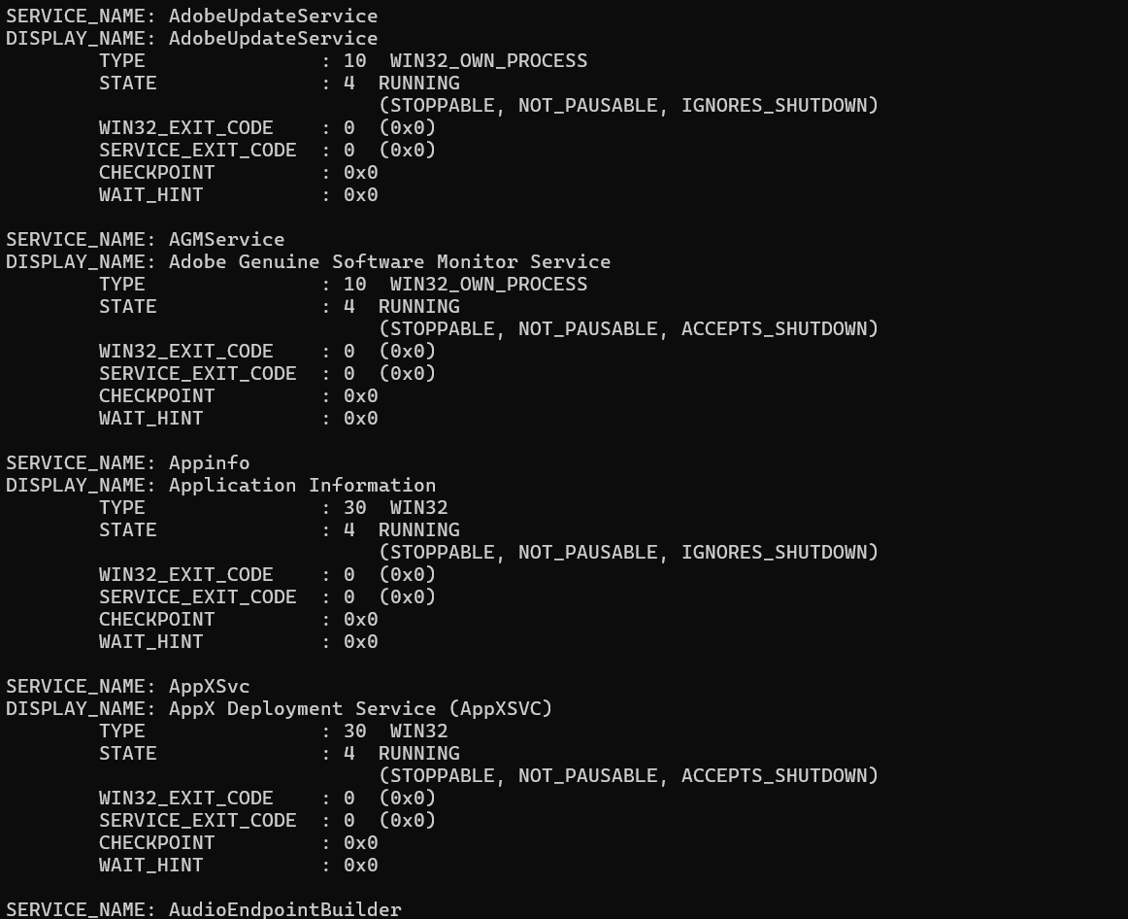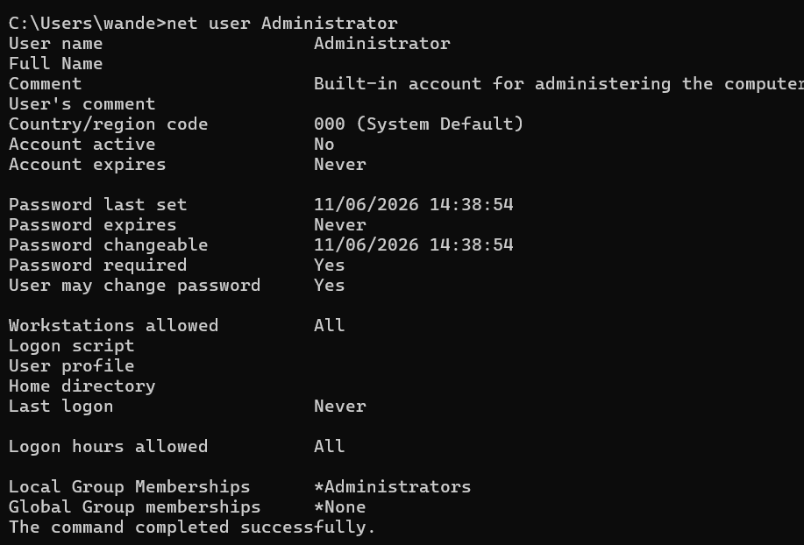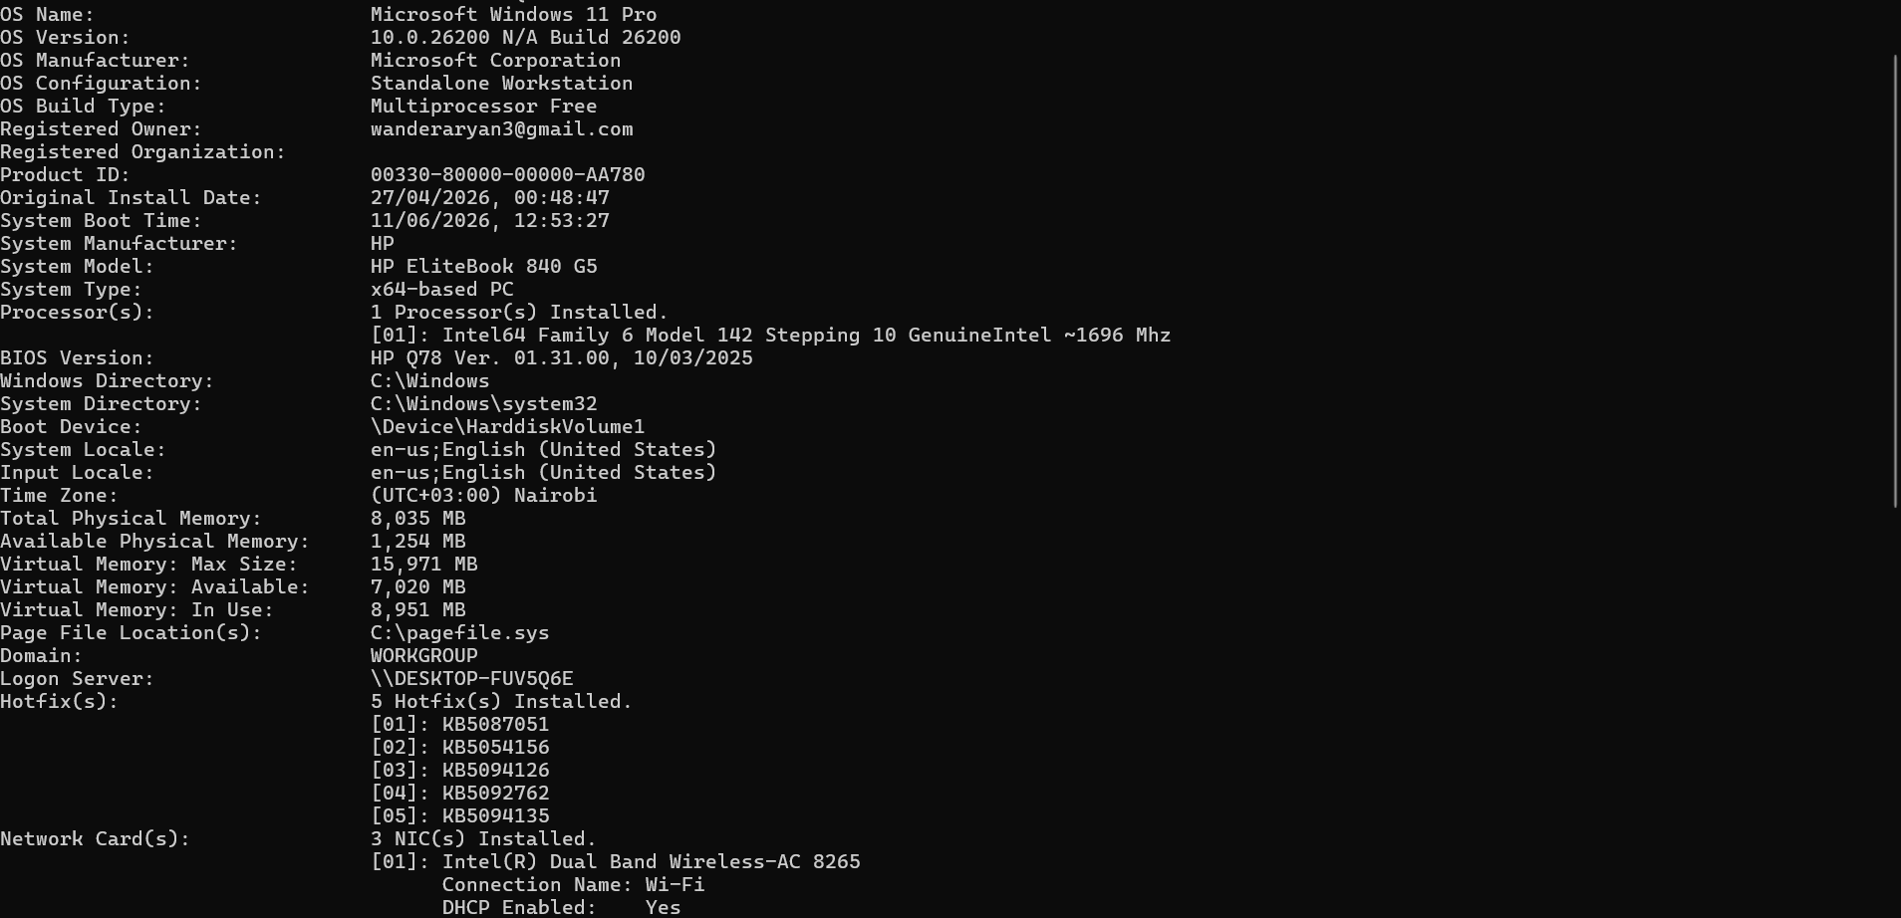
3. Enumerate Users and Services
Users Identified
Username | Account Type
Administrator | Local Administrator
Student | Standard User
Guest | Disabled
Running Services
Service | Status
Windows Update | Running
DNS Client | Running
DHCP Client | Running
Print Spooler | Running
Windows Defender | Running
Analysis
The system contained administrative and standard user accounts. Essential operating system services were active and functioning normally.
